|  |  |
| --- | --- |
| Product name | Confidentiality |
| Internal disclosure |
| VOG-L29 | Total pages: 8 |

**HUAWEI_hw-eu Software Upgrade Guideline**

|  |  |  |  |
| --- | --- | --- | --- |
| **Prepared By** | HUAWEI P30 Pro Team | Date | 2019-08-05 |
| **Reviewed By** | HUAWEI P30 Pro Team | Date | 2019-08-05 |
| **Approved By** | HUAWEI P30 Pro Team | Date | 2019-08-05 |



Huawei Technologies Co., Ltd.

All rights reserved

**Contents**

1 Update Precaution 3

1.1 Precaution 1 3

1.2 Precaution 2 3

2 Version Requirement 3

2.1 Previous Version 3

2.2 Upgrade Environment 3

2.3 List of the Files Involved in the Upgrade 3

3 Upgrade Preparation 4

3.1 Update Environment Check 4

3.2 Upgrade Package Check 4

4 Upgrade Description 4

5 Upgrade Execution 4

5.1 SD card Forcible Upgrade 4

5.2 OTG Forcible Upgrade 6

6 Verification and Troubleshooting 7

6.1 Version Check 7

6.2 Basic Function Check 7

6.3 Upgrade Issue Troubleshooting 8

# 1 Update Precaution

## 1.1 Precaution 1

Read the feature description before performing the upgrade.

1. Software version

Ensure that the current version of your phone's software is the original one. Otherwise the upgrade may fail or unknown errors may occur.

Do not attempt to update your phone to any customized versions for countries outside your country of residence. Otherwise the upgrade may fail or unknown errors may occur.

(2) Hardware version

This software is applicable to the *HUAWEI VOG-L29* phones only. If a phone of other models is used, the phone may not be powered on.

Huawei is not liable for failures caused by violation of the preceding precautions and no in-warranty maintenance will be granted.

## 1.2 Precaution 2

Upgrading your phone will erase all user data. Back up your data before the upgrade.

Ensure that the battery power is more than 30% at the beginning of the upgrade.

This upgrade guideline is applicable to same platform upgrade mode such as P-P or Q-Q, and does not apply to cross-platform upgrade mode such as O-P or P-Q.

# 2 Version Requirement

## 2.1 Previous Version

Version number bellowed this version can upgrade.

## 2.2 Upgrade Environment

For phone software applicable to *HUAWEI VOG-L29*, use SD card or OTG line and U disk to upgrade the phone to this version.

## 2.3 List of the Files Involved in the Upgrade

|  |  |
| --- | --- |
|  | **Document Name** |
| **Software Upgrade Package** | *dload*  *├─update_sd_base.zip*  *├─update_sd_cust_VOG-L29_hw_eu.zip*  *├─update_sd_preload_VOG-L29_hw_eu_R2.zip* |
| **Upgrade tool** | SD card or OTG line and U disk |

# 3 Upgrade Preparation

## 3.1 Update Environment Check

Suggest common method of using OTG line + U disk to upgrade, and also you can use SD card to upgrade if your phone supports SD extension.

1. If you use SD card to upgrade, check that the SD card is readable and writable, and its remaining space is larger than 8 GB. It is recommended that you use a Sandisk, Kingston, or Kingmax microSD card.

2. If you use OTG line + U disk to upgrade, check that the U disk is readable and writable, and its remaining space is larger than 8 GB. It is recommended that you use a Sandisk, Kingston, or Kingmax U disk card.

## 3.2 Upgrade Package Check

Refer to the preparation checklist in section 2.3 when checking the software upgrade package.

The directory structure of dload will be displayed as follows (check that the directory files are intact):

*└─dload*

*├─update_sd_base.zip (base package)*

*├─update_sd_cust_VOG-L29_hw_eu.zip (customization package)*

*├─update_sd_preload_VOG-L29_hw_eu_R2.zip (preload package)*

# 4 Upgrade Description

Upgrade method: forcible upgrade.

Forcible upgrade can be used on phones that have power-on failure and need restoration, or for other situations.

# 5 Upgrade Execution

## 5.1 SD card Forcible Upgrade

Step 1: Prepare a SD card with a capacity of at least 8 GB. A Sandisk, Kingston, or Kingmax SD card is recommended.

Step 2 (optional): Format the SD card to ensure the capacity is sufficient.

Step 3: Check that the directory of all files is intact in **dload**. Copy the dload document to the root directory in the microSD card.

Step 4: Check that the directory and files are intact in the SD card root directory.

Step 5: Power off the phone, insert the microSD card, and

For EMUI 9.X and Magic UI 2.X, press the VOLUME UP key, VOLUME DOWN key, and the POWER key all the three at the same time, until see the HUAWEI logo display. The phone enters the automatic upgrade mode, and the upgrade is started.

For EMUI 10.X and Magic UI 3.X, press the VOLUME UP key and the POWER key at the same time, then it will enter recovery interface, and then choose the “**Update mode** > **Memory card/OTG update mode”** to start the upgrade. If the product do not have the entity VOLUME key, just press the POWER key for more than five times when power on, then choose the “**Update mode** > **Memory card/OTG update mode”** to start the upgrade.

Step 6: During the upgrade, a progress icon will be displayed. After the progress icon is fully loaded, the phone will restart automatically, and the upgrade is completed.

Note: the SD card keep in connecting until the screen displays “Update success”.

For EMUI operating system, shows as below:

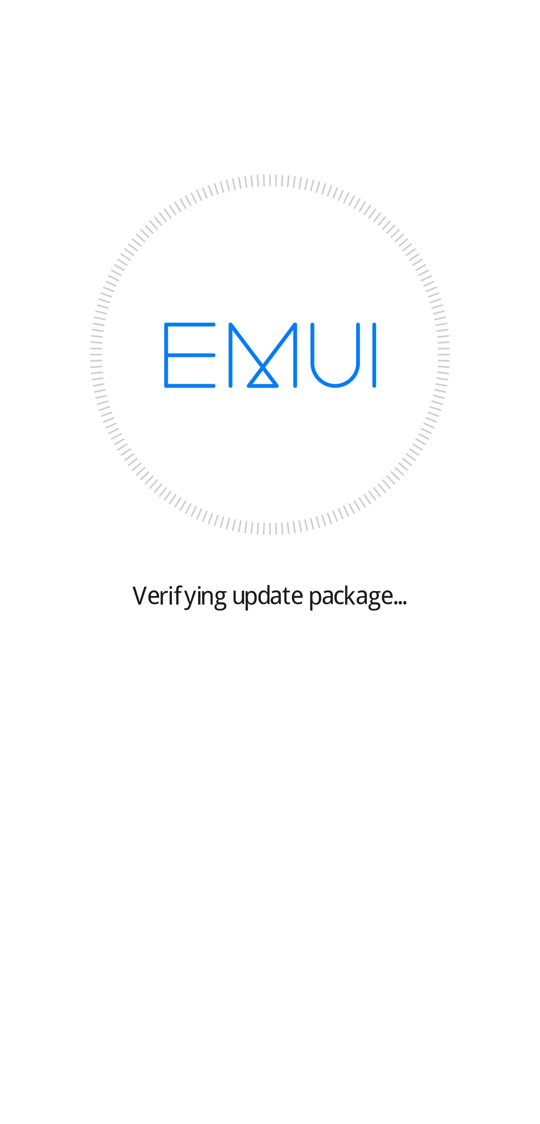 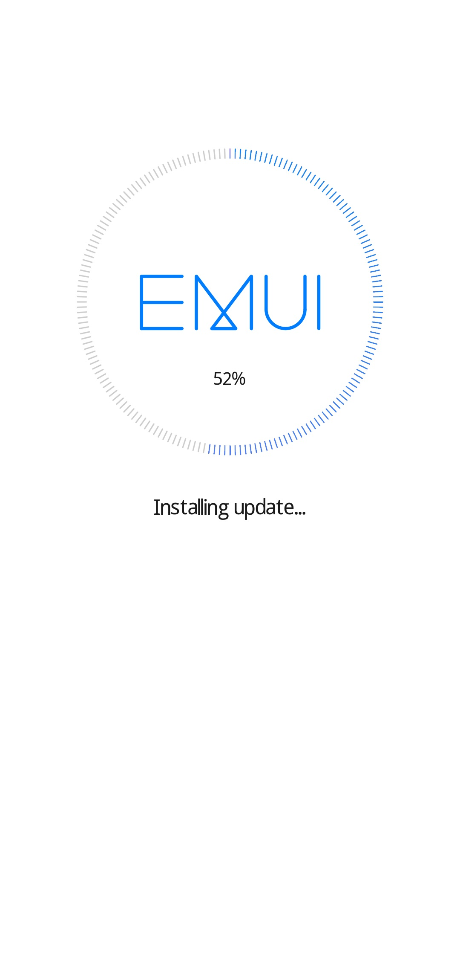 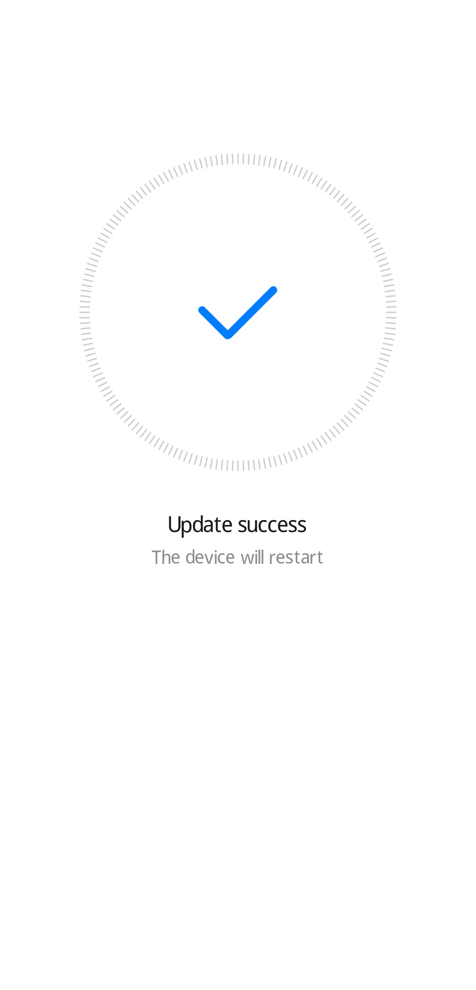

For Magic UI operating system, shows as below:

  

## 5.2 OTG Forcible Upgrade

Step 1: Prepare a U disk with a capacity of at least 8 GB. A Sandisk, Kingston, or Kingmax U disk is recommended. And an OTG line.

Step 2 (optional): Format the U disk to ensure the capacity is sufficient.

Step 3: Check that the directory of all files is intact in **dload**. Copy the dload document to the root directory in the U disk.

Step 4: Check that the directory and files are intact in the U disk root directory.

Step 5: Power off the phone, insert the OTG line & U disk, and

For EMUI 9.X and Magic UI 2.X, press the VOLUME UP key, VOLUME DOWN key, and the POWER key all the three at the same time, until see the HUAWEI logo display. The phone enters the automatic upgrade mode, and the upgrade is started.

For EMUI 10.X and Magic UI 3.X, press the VOLUME UP key and the POWER key at the same time, then it will enter recovery interface, and then choose the “**Update mode** > **Memory card/OTG update mode”** to start the upgrade. If the product do not have the entity VOLUME key, just press the POWER key for more than five times when power on, then choose the “**Update mode** > **Memory card/OTG update mode”** to start the upgrade.

Step 6: During the upgrade, a progress icon will be displayed. After the progress icon is fully loaded, the phone will restart automatically, and the upgrade is completed.

Note: the OTG line & U disk keep in connecting until the screen displays “Update success”.

For EMUI operating system, shows as below:

  

For Magic UI operating system, shows as below:

  

# 6 Verification and Troubleshooting

## 6.1 Version Check

When the phone is powered on, go to **Settings >System> About phone** > **Build number**, make sure the build version number is the same with the release version.

## 6.2 Basic Function Check

1. Power on the phone, enter the standby screen, and dial a phone number to make a phone call. Press and hold the End button to power off the phone. Check that these functions are normal.

2. Go over all the APK files and make sure that all of them function properly.

## 6.3 Upgrade Issue Troubleshooting

For an upgrade that follows the procedure and does not violate the precautions but failed, contact your local maintenance center. For details about maintenance centers, call the local Huawei service hotline. For information of the hotline numbers, visit the Huawei website:

<http://consumer.huawei.com/en/support/hotline/>